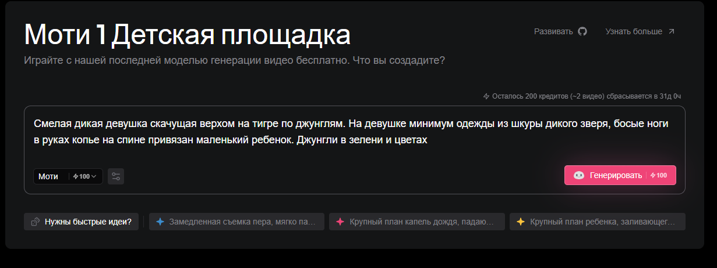
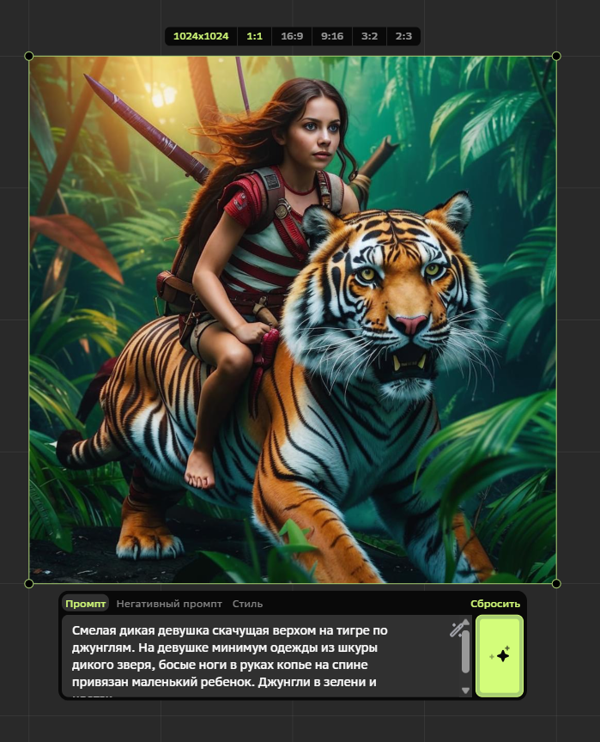
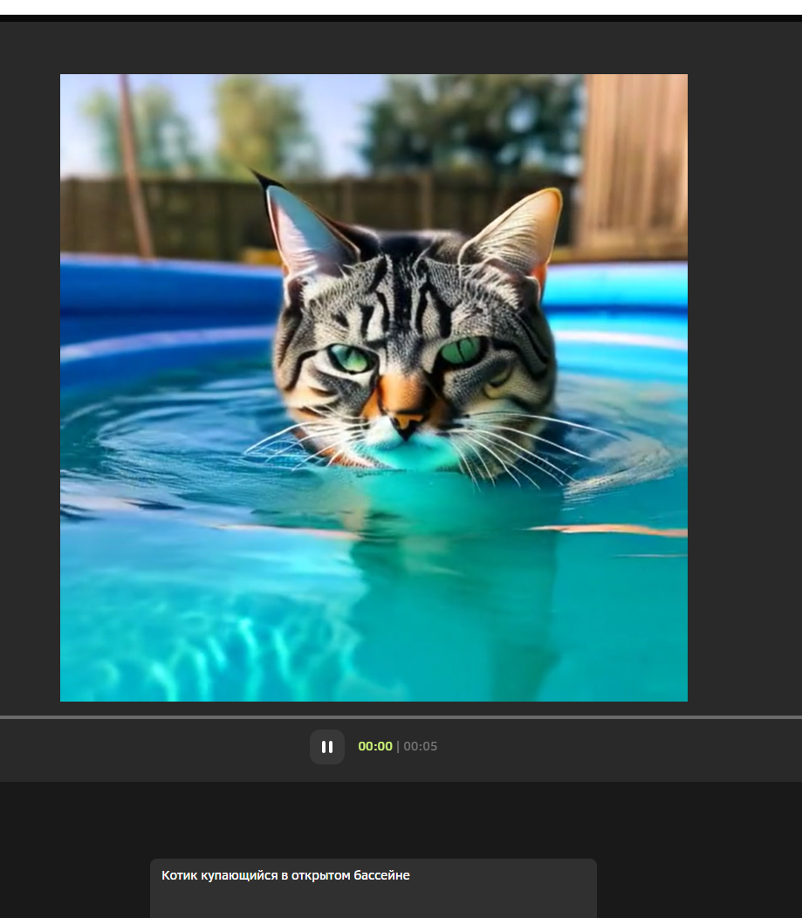

ССылки на видео:

https://drive.google.com/file/d/16jrmCRds5oiFtQh1xDR1O92f1mc4T4V0/view?usp=sharing

https://drive.google.com/file/d/1t_pBnRFkw1eqT8tzhT5V9JMBhGz8_HgD/view?usp=sharing

https://drive.google.com/file/d/1hInP8iAaMJsfmiCMhkA5AwWRZZPQ3M6k/view?usp=sharing

